Use-Case Realization Report (Analysis)
Give Change

Issue 3.0
Revision History
Date | Issue | Description | Author
13 July 2000 | 1.0 | First Issue | Howard Russon
2 August 2001 | 2.0 | Revised for MTech Unit 3 in 2001 | Howard Russon
21 July 2004 | 3.0 | Revised for MTech Unit 3 in 2004 | Howard Russon

Table of Contents
1. Brief Description 4
2. Flow of Events 4
2.1 Standard Flow 4
2.2 Exceptions 4
3. Interaction Diagrams 5
3.1 Collaboration Diagram: Give Change 5
4. Participating Objects 5
5. Class Diagrams 7
5.1 Class Diagram: Give Change 7
6. Derived Requirements 7

Use-Case Realization Report
Give Change

Brief Description
This abstract use case enables change to be issued to the Customer.

Flow of Events
The standard flow of events for this use case and any exceptions are described in the following subsections. The events are described in terms of Actors and Analysis Objects.

Standard Flow
This use case is used by use case Coin Input and Select Brand to give change to the Customer. The flow of events is shown in section 3.1 and described in the following sections.

The Change Giver will be instructed by the Transaction Controller to give change ( the change amount being provided by the Transaction Controller ) to the Customer. The Change Giver uses operation GiveChange to do this. The steps are as follows:
- The Cash Store will be instructed to issue change. Cash Store will use operation ReleaseChange to do this. To issue the change, the Cash Store will determine a suitable number of Coins to fulfill the required amount. It will then use operation ReleaseCoin of each chosen Coin to decrement the total number remaining in the Cash Store.
- If there is change available (partial or full amount), the total amount of money issued as change will be returned to the Change Giver. The Change Giver will then instruct the Refund/Change Tray Display to display the amount of money issued by using operation DisplayChange.
- If less than the required change can be issued, then the Change Giver will display "NO CHANGE AVAILABLE" on the Customer Panel by using operation DisplayNoChange of the No Change Available Display. Otherwise the operation InitialDisplay of No Change Available Display will be used to reset the display.
- The Change Giver will then use operation DisplayCoinQuantity of Store Controller to instruct it to update the coin denomination quantity display on the Cash Store Display of the Machinery Simulator Panel. The Store Controller will achieve this as follows for each denomination:
- Use operation GetQuantity of Cash Store to determine the total number of Coins of the denomination held. This in turn uses operation GetQuantity of the corresponding Coin.
- Use operation Update of Cash Store Display to display the value.
- Then the Total Money Inserted Display will be instructed to use its operation Update to reset the amount displayed to 0.00.
- Finally, the Change Giver will indicate a successful change give operation to the Transaction Controller.
- If a fault was detected while attempting to issue change, then the Cash Store and the various displays will not be updated. The Change Giver will indicate an unsuccessful change give operation to the Transaction Controller.

Exceptions
The following exceptions have been identified:
- Fault is Detected. As described in section 2.1, if a fault was detected while attempting to issue change, then the Cash Store and the various displays will not be updated. The Change Giver will indicate an unsuccessful change give operation to the Transaction Controller.
- Not Enough Change Available. As described in section 2.1, if less than the required amount of change is available, then whatever change can be given will be issued to the Customer. In addition, a sign saying NO CHANGE AVAILABLE will be displayed on the No Change Available Display.

Interaction Diagrams

Collaboration Diagram: Give Change
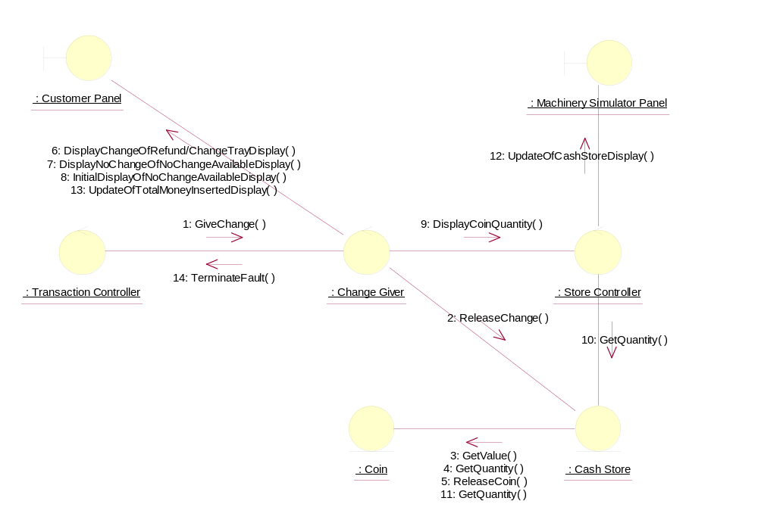

Participating Objects
: Cash Store
This object represents the store of cash in the vending machine.
: Change Giver
This control object manages the giving of change to the Customer.
: Coin
This object stores the weight and value of each type of Coin, and hence enables the machine to recognise each Coin entered.
: Customer Panel
This panel simulates the vending machine's customer interface panel. It will enable the user (the Customer) to:
1 insert coins;
2 select brands;
3 terminate transaction.
It will also provide the following display functions:
1 display total money inserted;
2 indicate coin not valid;
3 indicate no change available;
4 display the value of the change to be collected;
5 display an icon representing the dispensed drink.
: Machinery Simulator Panel
This panel simulates the physical actions of the maintainer. It enables the user to:
1 display and enter new values for the number of cans of each Drinks Brand held by the Drinks Store;
2 display and enter new values for the number of Coins of each denomination held by the Cash Store;
3 display whether the vending machine Door is unlocked, and enable it to be locked.
: Store Controller
This object controls the Change State use case. It mangages changes in Cash Store attributes and the Drinks Store attributes. It also handles the door status. It is also used by the Dispense Drink use case to update the Drinks Store attributes.
: Transaction Controller
This control object coordinates the customer transactions for selection of a drink brand, coin input, storage of coins and termination requests for ongoing transactions.

Class Diagrams

Class Diagram: Give Change
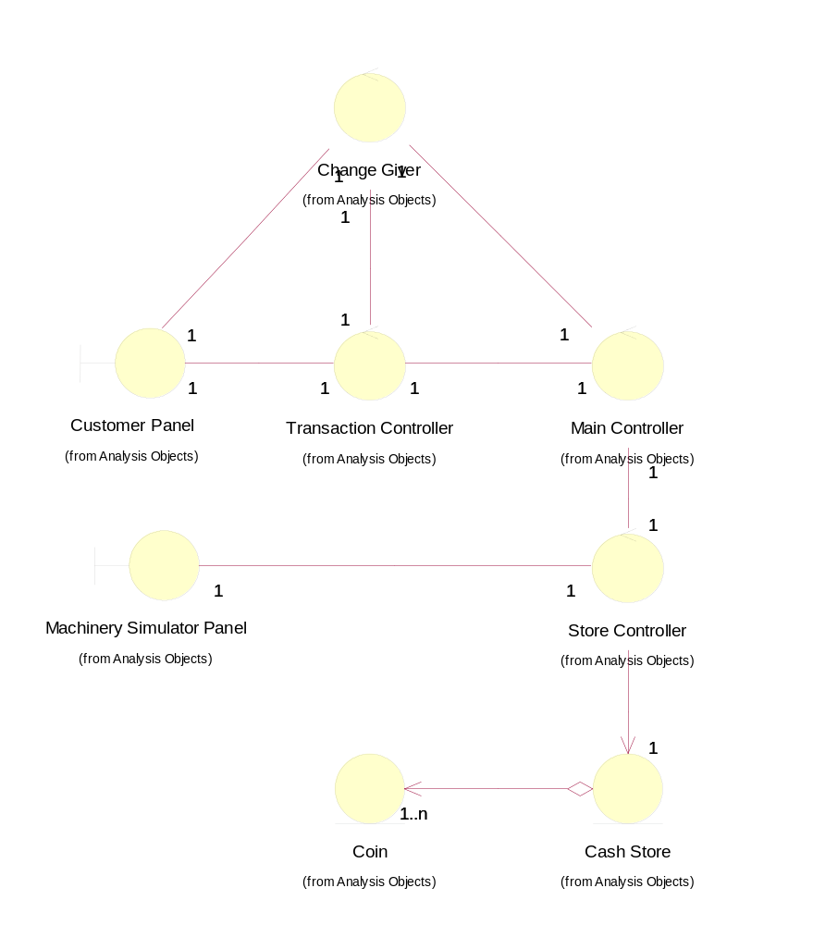

Derived Requirements
There are no special requirements associated with the host implementation. However, in the target implementation a cash try is required to be built into the Maintenance Panel.

